- Unpack metal stand and place in the upright position.
- Screw 3/8” threaded pipe into the top of the metal base until it tight.
- Position lock washer on threaded pipe.
- Tighten hex nut with wrench
- Position art glass over 3/8” threaded pipe.
- Place rubber, steel, and lock washer onto threaded pipe. Hand tighten hex nut until firmly mounted. (Do not use a wrench)
- Lay lamp down on its side so that the electrical cover plate is accessible being careful not to put any pressure on the glass.
- Feed socket assembly wires down through the nipple until they appear through the electrical box on the bottom of the lamp base. ***A silver feeder wire is attached to the socket assembly for ease in sliding electrical wires through lamp base. Once socket assembly wires are in place carefully unwind stripped electrical wires from feeder and proceed to next step. Retain feeder for reassembly.
- Screw socket assembly onto 3/8” threaded rod.
- Attach wires from socket assembly to wires of the slide dimmer. Tighten wire nuts securely and attach cover plate on the bottom of the lamp base.

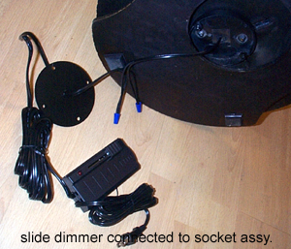

- Screw in 250 watt halogen bulb making sure not to touch it with your bare hands. If touched clean with alcohol.
- Plug cord in wall outlet. Red light on dimmer switch will go on. Note: If light bulb burns out the red light on the dimmer switch will turn off.

